1.9 Teacher Tool Box- Flipsnack Preparation
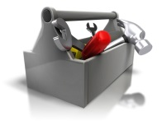

Creating a digital flipsnack to review Needs Assessment Progress

Why a flipsnack?

There are many different ways for students to document the progression of their service-learning projects that are all perfectly fine. Remember the goal of the needs assessment is not only for the students to be able to have a good understanding of the needs within the community and determine a viable project. The documentation is a way to have a sustainable presence of the EPICS model within your school and community. When the students create a flipsnack, they are not only documenting the needs of the community and the potential project in word, they are also creating a pdf version that is easily converted into a flash format, all of this FREE! This will allow for a repository of developed project that can be used by future students without having to start from scratch.
In the pages that follow, you will find step by step directions on how to create a flipsnack.
Creating an Account
You must sign up for flipsnack and create an account
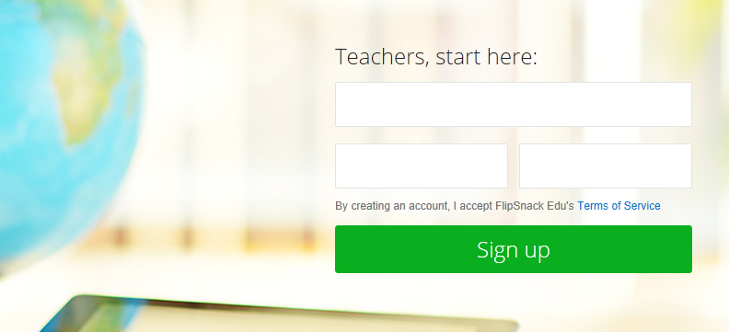
The first line is for your e-mail account
Create a password then reenter the created password.

Validate your account
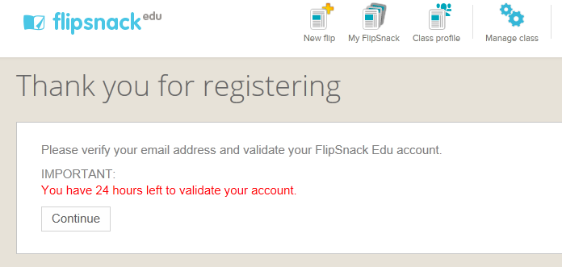
Check your e-mail and verify and click on the link to confirm your account.

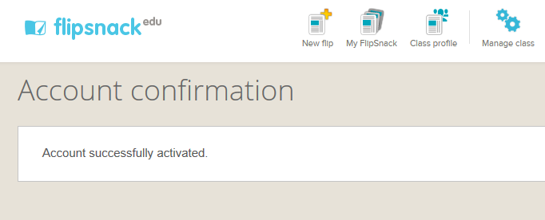
After you have checked your e-mail and validated your account, you are ready to begin to create your flipsnack.

FlipSnack Edu
Here is a link to the web page for Flipsnack that will give you downloadable PDF guides and help booklets for you and your students.
http://flipsnackedu.com/guides.html
How to make a PDF document
Here is the easiest way to create a PDF if you have Microsoft Office, 2003 or higher.
Creating your document- You will need to take all of the documents that you have created for the different phases of the design cycle and all of the documents you have created for the needs assessments.
Save your document before saving to PDF
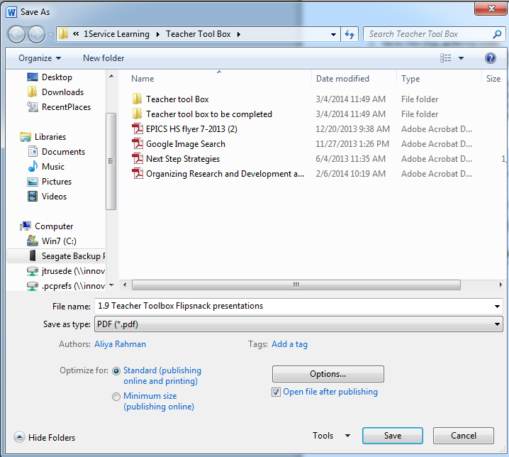
- File
- Save
- Enter
Save your document as a PDF
- File
- Save as
- PDF
- Enter

How to make the actual flipbook
- Log in to your account at edu.flipsnack.com or flipsnack.com.
- New Flip- Go to New Flip in the top menu.
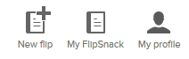
- Upload your files- you can add PDF, JPG and JPEG. You can add one or more documents. 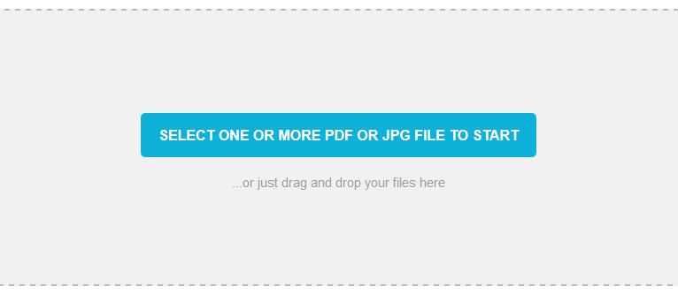
- Combine documents- You can combine the documents to create a complete synopsis of your project by continuing to add PDF versions of your project documents.
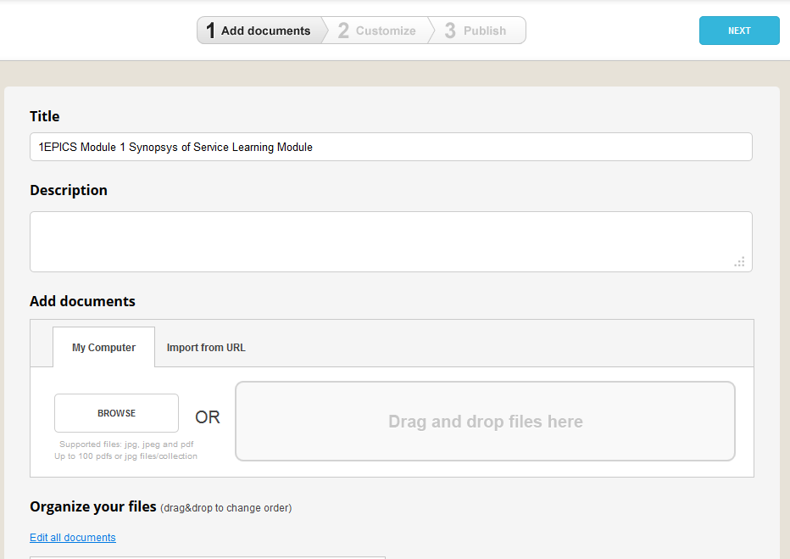
- Customize- choose your settings (if you uploaded multiple files, you can merge them into a single flip book by checking the appropriate box), cover and background color
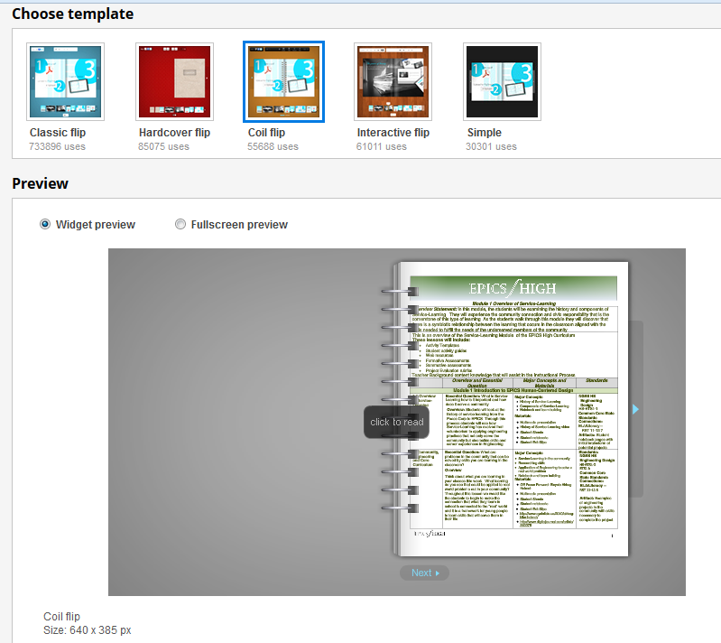

- Additional Settings- For consistency of the document, you may want to merge all files into one, as an option.
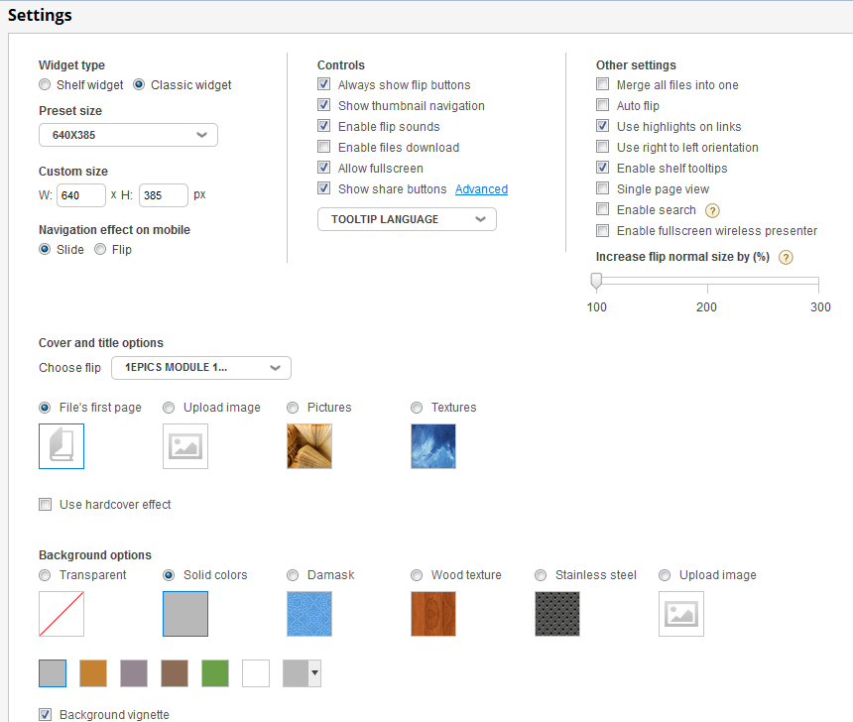
- Click Finish- You can now choose to show your Flipbook on the Browse page or not. You can also activate download options here.
8. Sending the link- After you have created your flipsnack you will need to send the link, copy it and insert it in your web page.
To download is a premium option, which is rather expensive.
The embed button allows you to retrieve the code so the flipsnack can be embedded in your web page.
Share allows you to share the link to your flipsnack with others. This would probably be the best option to share your reflections with your teacher.
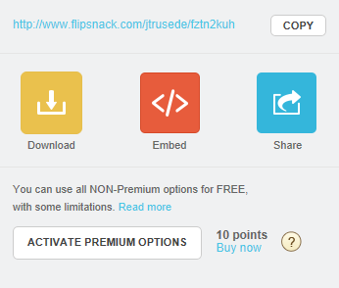

- Preview document- As you preview the document, you may want to change the name of your flipsnack to represent your project for easier accessibility.
